1. Define a computer network. What are its main purposes?

* Computer network is a physical and logical interconnectedness among a computers, and other connective devices and different servers through communication medium and same protocol. Its main purpose is to send and receive data, for resource (like physical devices and software) sharing and enhanced data security.

2. What is the difference between LAN, WAN, MAN, and PAN? Provide one example

of each

LAN-means a local area network. As the name indicates it covers a very small amount of area. Such as a home WIFI with a very high speed. It is mainly a private network, but MAN refers to metropolitan area network that covers a relatively large mount of network as compared as LAN and smaller when we compare it with WAN. Usually, it covers a city-wide coverage with high kilometer radius, example- city network while, WAN is global and covers a wide number of kilometers. It connects several cities, countries even continents. It’s network of different LANs and WANs networks. Example- Internet. PAN refers to personal area networks which are not over 10 meters such as blue tooth connection between two phones.

3. Explain client-server and peer-to-peer network models with

Examples

* Client server models contain two types of computers that differs with capacity and degree of control over the network. Clients are ordinary computers that send data to another device through the server. Servers are computers with huge capacity and server software which act as the master device on the network which monitors the security, resources and data flow. for each device on this model that want to access resources they must first ask the server. For example- Email Service, Browsing or Web service, Mobile Banking.
* Peer to peer model contains of different devices and computers with the same degree of control over the network. Each device has access to define its security and data flow and also what resource to share to the network. For example- Lan File sharing within 2 pcs, Bit torrent.

4. What are the benefits of using a network in an organization?

* Sharing of different hardware like printer, and several softwares with high subscription fees to allocate for all other devices.
* Resource sharing for high computing power demanded works.
* For security Reasons

Network Topologies

5. 6. 7. List and explain four common network topologies.

* Bus- is a network topology with treelike structure one backbone strong network cable trans port data among devices that branch out through the network. The reliability of data, failure of network and all other basic issues are aligned with the cable. A failure of any device doesn’t affect the functionality of the network,
* Ring- a network topology that follows peer to peer model and a group of computers each back and forth connected with other computer to form a loop like structure. when one device sends a data then every other device next to the origin passes it until we get the intended receiver.
* Star- All devices are connected to a central device (hub/switch).If one device fails, others are unaffected, but if the central hub fails, the whole network goes down. The other thing to remind is it’s easy to install and manage.
* Mesh - Every device is connected directly to every other device. It is highly reliable (if one link fails, data can take another path). when we go to the drawback it is highly expensive and complex due to many connections.

Network Devices

Draw a star and bus topology. Mention one advantage and one disadvantage of each.

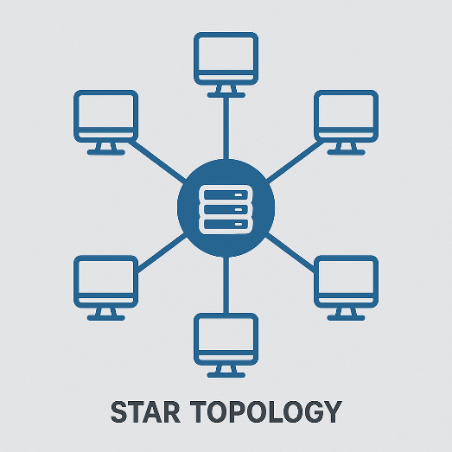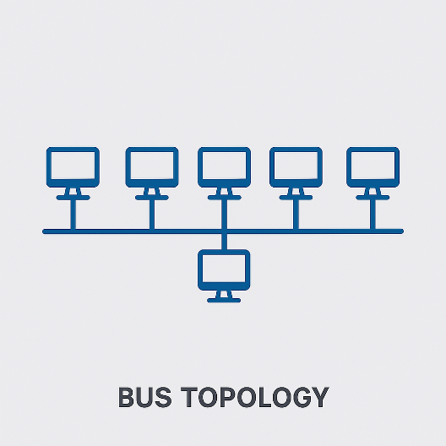

* Advantage to a star topology is There is a centralized management of the network and when we come to the disadvantage if the central hub/switch fails the whole network couldn’t function.
* Advantage of bus topology is it is easy to set up and cost effective but if the backbone cable has a problem the whole network will go down.

Which topology is most commonly used in modern LANs? Why?

* Most of today’s LANs use star topology because it has agood performance, easy to install and reliable.

8.. Define the function of the following devices:

Switch- manage the network traffic of LANs by determining the best path of frames among a single network.

Router- function as a network manager of multiple networks. If a router exists mostly there are at least two networks. It helps to determining the best path for packets or routing.

Hub-hub is a central device used as a path to data units and are used to broadcast data.

Access Point =is a device used to convert a wired network to wireless.

9. What is the difference between a modem and a router?

* Modem converts signals between personal network and the isp or it connects us with the internet. But router used to manage internal network.

10. Which OSI layers do a switch and router operate on?

* Switch-Layer 2
* Router-Layer 3

11. What are the types of transmission media in networking? Give examples.

* There are two types of transmission media. The first is guided or wired example: Twisted pair, coaxial and fiberoptic cables. and the second is unguided or wireless media examples- microwaves and infrared.

12. Compare STP and UTP cables.

* STP cables are more strong and have a better shield, these cables are greater noise cancellation power but UTP cables have less noise cancellation and less shield than STP.

13. What ae BNC and RJ45 connectors used for?

* We use BNC connectors to connect two coaxial cables and CCTV systems, radio, and some legacy LANs (like 10BASE2) and we use RJ45 connectors to connect UTP cables to connect two network devices.

14. Explain the difference between single-mode and multi-mode fiber optic cables.

* Single-mode fiber has a very thin core (about 8–10 microns) and uses laser light to transmit data over long distances, often exceeding 100 kilometers. It provides higher bandwidth and is commonly used in telecommunications, long-haul networks, and ISP backbones. On the other hand, multimode fiber has a thicker core (around 50–62.5 microns) and uses LED light for data transmission over shorter distances, usually up to 2 kilometers. It is widely used in LANs, campus networks, and data centers

15. What are the typical uses of coaxial cable in networking?

* Coaxial Cables are used as a backbone on bus topology, as tv cable, on broadband internet, on CCTV camera function.

16. List the color codes used in T568A and T568B Ethernet cable standards.

In the T568A standard, the pin assignments and corresponding wire colors are: Pin 1 – White/Green, Pin 2 – Green, Pin 3 – White/Orange, Pin 4 – Blue, Pin 5 – White/Blue, Pin 6 – Orange, Pin 7 – White/Brown, and Pin 8 – Brown. In contrast, the T568B standard uses the following order: Pin 1 – White/Orange, Pin 2 – Orange, Pin 3 – White/Green, Pin 4 – Blue, Pin 5 – White/Blue, Pin 6 – Green, Pin 7 – White/Brown, and Pin 8 – Brown.

17. What is the purpose of crossover and straight-through cables? When are they used?

We use straight through cables if we want to connect two different kind of network devices in contrast, we use cross over mainly to connect two same network devices .

**Straight-** computer to a switch, a computer to a router, or a switch to a router

**Crossover-** computer to another computer, or a switch to another switch

18. Name three tools used to prepare and test Ethernet cable

* a crimping tool, a cable tester, and a wire stripper

19. Describe the three types of communication flows: Simplex, Half-Duplex, and Full

Duplex.

* **Simplex**- one party is always a sender and the other is a receiver. there is no feedback or response from the other party
* **Half- Duplex**-there is two-way communication but not at the same time.
* **Full-Duplex**- two-way communication simultaneously

20. What are the key components of a basic communication system?

Sender, message, protocol, media, receiver

21. Why are protocols important in communication?

* Because protocols are rules in which states how the communication system works. With out these rules there will not be information exchange.

22. List and explain the 7 layers of the OSI model.

**Application**-provide network services to the applications users are interacted.

**Presentation**-Data is Translated, encrypted and compressed.

**Session**-Creates Session, maintain and end sessions.

**Transport**- Ensures reliable data transfer between systems and Provides error checking, flow control, segmentation/reassembly

**Network**-deal with packets, choosing the best path for packets and forward those packets. In general routing is occurred.

**Data-link**-deal with frames- Switching, mac addressing, Error detection/correction (CRC), Flow control and Frame synchronization

**Physica**l-converts frames into bits, physical layout of a network.

23. Match the following protocols to OSI layers: HTTP, IP, TCP, Ethernet,

DNS, ARP

* Application-HTTP, DNS
* Transport-TCP
* Network-IP
* Data-Link-ARP
* Physical-Ethernet

24. What is the function of the Transport layer? Name two protocols

used there.

* Transport layer Ensures reliable data transfer between systems and Provides error checking, flow control, segmentation/reassembly.eg. TCP, UDP

25. Compare OSI and TCP/IP models. Mention one similarity and one

difference.

* Both models are layered architectures designed to standardize and guide how data communication happens across networks by dividing the process into smaller, manageable layers. Their difference is OSI has 7 layers but TCP has 4 layers

26. What are the layers of the TCP/IP model?

* Application, Transport, Internet, Link

27. In which layer is IP addressing handled in OSI and TCP/IP models

* Network layer of OSI model and Internet Layer of TCP.

28. What is an IP address? Differentiate between IPv4 and IPv6.

* IP address is a unique number assigned to devices on a network to identify and communicate with each other.
* The difference between IPv4 and IPv6 is IPv4 uses 32-bit numbers and has fewer addresses but IPv6 uses 128-bit numbers and provides many more addresses.

29. Convert 192.168.1.1 to binary.

* 11000000.10101000.00000001.00000001

30. Convert 11000000.10101000.00000001.00000100 to decimal.

* 192.168.1.4

31. Define the IP classes A, B, and C with their address ranges.

* Class A: 1.0.0.0 to 126.255.255.255
* Class B: 128.0.0.0 to 191.255.255.255
* Class C: 192.0.0.0 to 223.255.255.255

32. What is the difference between static and dynamic IP addressing?

* Static Ip is Manually assigned and has a fixed IP address. but Dynamic IP is automatically assigned by DHCP, can change over time.

33. What is a private IP address? List the private IP ranges.

* IPs used within local networks, not routable on the internet.

Private IP Address Ranges:

* 10.0.0.0 – 10.255.255.255
* 172.16.0.0 – 172.31.255.255
* 192.168.0.0 – 192.168.255.255

34. What is the loopback address and what is it used for?

* Loop back address is address with Ip 127.0.0.1 and it is used to test the local network interface on a device (self-communication).

35. How many hosts can a /24 subnet support?

* 254 hosts

36. What is the subnet mask of /26? How many hosts does it support?

* Subnet mask: 255.255.255.192
* Hosts supported: 62

37. Calculate the network and broadcast address of 192.168.20.0/27.

* Network address: 192.168.20.0
* Broadcast address: 192.168.20.31

38. From a /24 network, how many subnets can you create by borrowing 3 bits?

* 8 subnets

39. What is a MAC address and how is it different from an IP address?

* MAC address is a unique hardware identifier assigned to a network device’s NIC. Their difference is MAC address is fixed and works in layer 2 but Ip address id dynamic and works in layer 3.

40. What is ARP and what is its role in networking?

ARP (Address Resolution Protocol) translates IP addresses into MAC addresses on a local network, which enables devices to find each other’s hardware addresses.

41. What does HTTP do? On which port does it operate?

* HTTP (Hyper Text Transfer Protocol) is used to transfer web pages and files on the internet and its port no is 80.
* 42. What is DNS? What problem does it solve in networking?
* DNS (Domain Name System) translates easy-to-remember domain names (like google.com) into IP addresses while peoples go through the internet and using web services. It solves the problem of remembering numeric IP addresses.

43. Define DHCP HOW does it help in IP configuration?

Dynamic Host Configuration Protocol id a layer7 protocol used to assign ip addresses to devices dynamically.

44. List five common networking protocols and their functions.

* HTTP – Web page transfer
* FTP – File transfer
* SMTP – Sending emails
* TCP – Reliable data transport
* IP – Routing and addressing

45. What is the difference between switching and routing?

* Switching connects devices within the same network, forwarding data based on MAC addresses. On the other hand, Routing connects different networks, forwarding data based on IP addresses

46. Define VLAN. What is its purpose in a network?

* A VLAN (Virtual Local Area Network) is a logical group of devices on the same network. Its purpose is It improves security, reduces broadcast traffic, and helps organize the network by separating departments or functions.

47. What is default gateway and why is it important

* A default gateway is the device (usually a router) that connects a local network to other networks. It is important because it allows devices in one network to communicate with devices outside their local network.

48. Name three common types of network threats.

* **Malware** – harmful software like viruses or worms.
* **Phishing** – tricking users to give up sensitive information.
* **Denial of Service (DoS)** – flooding a network to make it unavailable.

49. What is a firewall? How does it protect a network?

* A firewall is a security system that monitors and controls incoming and outgoing network traffic. It protects the network by blocking unauthorized access and allowing only safe traffic.

50. What is the role of antivirus software in networking?

* in networking, it helps prevent infected devices from spreading threats across the network.

51. Explain what NAT (Network Address Translation) is and where it is commonly used.

* NAT is a process that modifies network address information in IP packet headers as they travel across a routing device. It allows multiple devices on a private network to share a single public IP address when communicating with the internet.